6A^{th} Grade: Unit 11, Lesson 4

- Is this a correct equivalence?
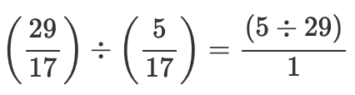

No

- What is the result of this equation?
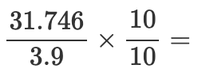

$$\frac{317.46}{39}$$

- Is this a valid progression of a problem?
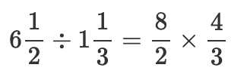

No

